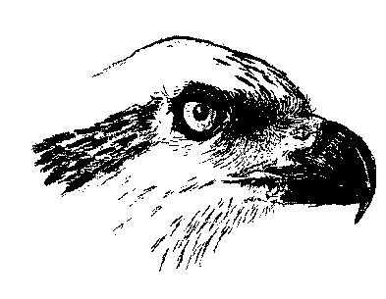 Registration Form for
Osprey Archery Club Introductory Training
_______________________________________________________________

Date: _____________________

Introductory Training:

$50.00 for one 90 minute session

 | ANS # | Family Name | First name | Gender | Date of Birth
1
2
3
4

Address, City
Province, Postal code
Home phone #: | Mobile phone#
E-mail:
Club Name: | Osprey Archery Club

COVID 19 Proof of Vaccine: In accordance with Sports Nova Scotia and Archery Nova Scotia, any person 13 years of age or older, must be able to show “Proof of full vaccination (2 shots) for people attending and participating in sport activities”

_________________________________ ____________________________________
Print Name Signature

Contacts

Ospreyarcheryreg@gmail.com - for additional information

ospreyarcherytres@gmail.com – etransfers (use “Osprey” as security code)

