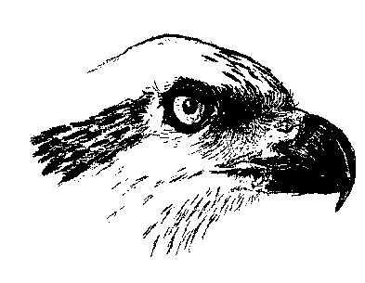 2024
Membership Registration Form for
Osprey Archery Club
_____________________________________________________________________________

Date: ____________________

Membership Type: (Person(s) listed below MUST have a current Membership with Archery Nova Scotia prior to application – due to Insurance liability)

Individual: Full year (January 1 to December 31) $200.00
Half year (July 1 to December 31) $100.00

Family* Full year (January 1 to December 31) $300.00
Half year (July 1 to December 31) $150.00

Total payment included: $__________

*According to Osprey Archery club, family membership includes any individuals living at the same permanent address, including youth up to age 24 years of age.
According to ANS, family membership includes two or more members of the same family for this classification so long as the children are under the age of 18 and will remain under the age of 18 in the year of membership.

 | ANS # | Family Name | First name | Gender | Date of Birth
1
2
3
4

Address, City
Province, Postal Code
Home phone #: | Mobile Phone#
E-mail:
Club Name: | Osprey Archery Club

Instructions:

1. ANS number MUST be listed and the ANS membership MUST be current prior to the application being processed due to insurance and liability coverage.

2. By providing your e-mail address you are giving permission to Osprey and AANS to send you e-mail updates.

3. Send the completed application and payment to:
ospreyarcherytres@gmail.com (e-transfer your payment use “Osprey” as security code) or by cheque mailed to:
Osprey Archery Club 4093 Prospect Road, Shad Bay, Nova Scotia, B3T 2C1

More information about Archery Canada & Archery Nova Scotia is available from:

Archery Nova Scotia - www.archeryns.ca
Full membership information, including the digital cards, can be found in your 2M profile under Memberships & Licenses

Archery Canada - www.archerycanada.ca

